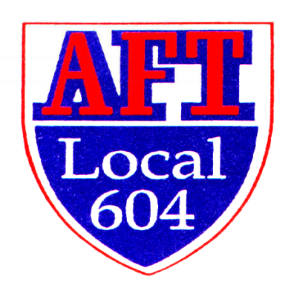
Richard Manley Scholarship Application
For Current Support Staff Members
Awarded by AFT Local 604

The Richard Manley Support Staff Scholarship is in honor of a man who built AFT Local 604 into the position of respect it holds today not only in Illinois, but also the American Federation of Teachers. Anyone who knew or met Dick realized his passion for AFT Local 604 and our members. Dick served as president of AFT Local 604 when it merged with Local 1291 from April of 1976 until his retirement in January of 2018. Before that, he was president of Lockport Federation of Teachers Local 1291 starting in 1969. He began his teaching career at Serena High School before moving to Lockport Township High School, where he taught physics for 34 years. During his leadership, AFT Local 604 became the second largest local in the IFT and the 14th largest in the AFT with over 11,000 members and 75 councils in 10 counties.

AFT Local 604 is offering at least one scholarship for up to $2,000. The scholarship application is due in the Local office Monday, November 13th, 2025. The winner will be announced at the February 18th Senate meeting. Applicants must be a current support staff member in good standing in AFT Local 604. He/she must be pursuing a bachelor’s or master’s degree in an education field with the desire to become a professional classroom educator or take classes directly related to his/her position in the district.

Rules and Requirements:
- Completed, typed application must be in AFT Local 604 office on or before
- November 13th , 2025.
- Applicants must have at least three consecutive years of full-time service to the district
- All requested information must be included at one time with the application
- The essay should not exceed 500 words
- Letter of Recommendation from a Union officer
- Review the Rubric and explain both your Union and Community Involvement

Essay: In no more than 500 words, explain your motivation in pursuing this academic study. In addition, describe how you anticipate working more effectively in the district after you complete your courses.

Checklist
- Typed application
- Typed essay
- Letter of Recommendation
- Review of the Rubric
- Explanation of your involvement in your school and/or community
Richard Manley Support Staff Scholarship Application—page 2

Date ____________

First Name ______________________ Last Name _________________________________

Mailing Address ________________________________________________________________

City, State, Zip _________________________________________________________________

Personal E-mail ___________________ Cell Phone ________________________________

Your Council Name _____________________________________________________________

Your Council President’s Name ____________________________________________________

In what district are you employed ________________________ How many years ____________

Current Position ________________________________________________________________

What university/college would/are you attending_______________________________________

What is the program’s title if applicable _____________________________________________

If selected as a recipient, what classes will you be taking? _______________________________

______________________________________________________________________________

Applicant Signature: _____________________________________________________________

AFT Local 604
1520 N. Rock Run Drive #1
Crest Hill, IL 60403-3232
815-725-0402

